Clock-In / Clock-Out Guide

# For Employees

* It is absolutely required to clock in and clock out correctly. Failure to do so may result in delays on you getting paid.
* When you log in to Paylocity, you should always have a large prompt on your screen displaying the “Time Clock.” Click the “Clock In” button at the beginning of your shift.

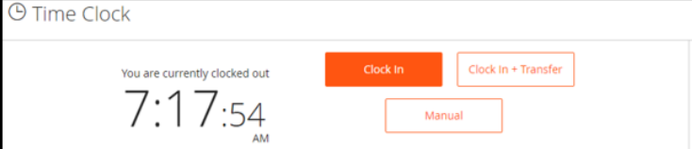

* You will need to “Clock Out” if any of the following are true:
  + You are done for the day.
  + You are taking a meal break.
  + You are moving to another building to complete the next part of your shift.
* If you work in more than one building during a given day, use the “Clock in + Transfer” button, ONLY if this is the second time you are clocking in today. Always use “Clock In” if it is your first clock in of the day.
* If you forget to clock in when you first start your shift, you can use the “Manual” button to clock in. Bear in mind that you will need to have your Administrator correct the time to the correct start time.
  + After clicking the “Manual” button, you’ll click “Punch,” followed by the Punch Type (Clock In, Clock In + Transfer, or Clock Out).

For additional help, please see the [Quick Reference Employee Guide](https://docs.paylocity.com/webtime/admin/PDFs/Web_Time_Employee_Dashboard_Quick_Reference_Guide.pdf) from Paylocity.

# For Administrators

* It is the employee’s responsibility to ensure that they are clocking in and clocking out correctly. However, it is your job as the Administrator to ensure that the information is accurate and complete.
* Accurate: You will need to review each employee’s timecard, either [individually](https://docs.paylocity.com/mergedProjects/Web_Time_Main/mergedProjects/Web_Time_Supervisor_Guide/Employee_Time_Card/Approve_Employee_Timecard.htm) or as a [group](https://docs.paylocity.com/mergedProjects/Web_Time_Main/mergedProjects/Web_Time_Supervisor_Guide/Timecard_Approvals/Timecard_Approvals.htm). This is particularly true where employees may work in more buildings than just yours, and you’ll want to ensure that only the hours where they’re working in your building are showing up for you to approve.
* Complete: Resolve [Missed Punches](https://docs.paylocity.com/mergedProjects/Web_Time_Main/mergedProjects/Web_Time_Supervisor_Guide/Supervisor_Dashboard/Missed_Punches.htm) on a daily basis, as they interfere with our ability to complete payroll.
* If an employee is having a lot of difficulty in clocking in and out, you can enter a timecard on their behalf in case of emergency (e.g. the Thursday prior to a payroll run). However, it is generally inadvisable to do this routinely, as it lends itself to error (getting the exact time of the clock in correctly), and also increases your personal liability in the event of a review of hours.