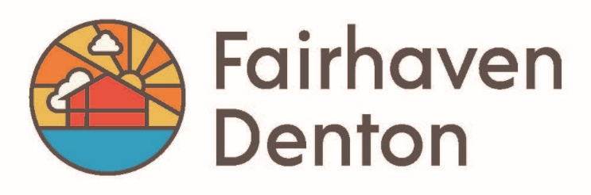

Employee Reprimand/Performance Improvement
Employee Information
Employee Name: | Date:
Job Title: | Manager:
Location: | Administrator:

Type of Warning
- First Warning (Verbal) | - Second Warning |  | - Final Warning |  | - Suspension
Type of Offenses
- Tardiness/Leaving Early |  | - Absenteeism |  | - Violation of Company Policies
- Substandard Work |  | - Violation of Safety Rules |  | - Rudeness to Customers/Coworkers
Details

Description of Infraction:

Plan for Improvement:

Consequences of Further Infractions:

Acknowledgement of Receipt of Warnings

By signing this form, you confirm that you understand the information in this warning. You also confirm that you and your manager have discussed the warning and a plan for improvement. Signing this form does not necessarily indicate that you agree with this warning.

Employee Signature Date

Manager Signature Date

Witness Signature (if employee understands warning but refuses to sign) Date

