

PATCH APPLICATION AND DOCUMENTATION

Resident: _____________________________________­­­­­­­____________

Medication (name, dosage, directions): ___________________________________________________________________

__________________________________________________________________________________________________

|  |  |  |
| --- | --- | --- |
| **DATE & TIME** | **LOCATION** | **INITIAL** |
|  | **1** |  |
|  | **2** |  |
|  | **3** |  |
|  | **4** |  |
|  | **5** |  |
|  | **6** |  |
|  | **7** |  |
|  | **8** |  |

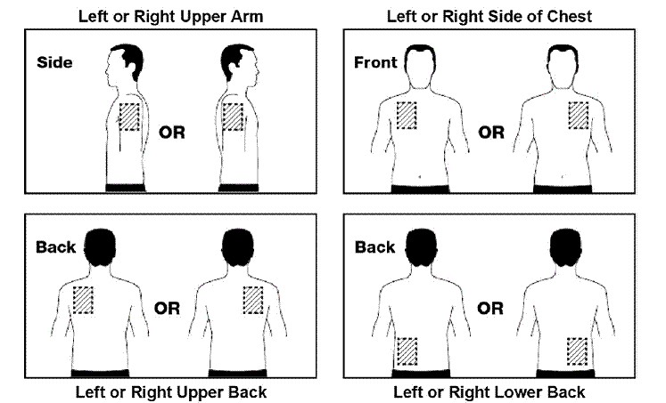

8

7

6

5

4

3

2

1